2.65: For the first 5.0 s of the motion, 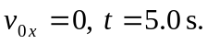
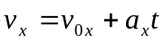 gives 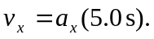
This is the initial speed for the second 5.0 s of the motion. For the second 5.0 s:

Use this a_{x} and consider the first 5.0 s of the motion:

